A. Rates of reaction: Practical methods and calculating rates of reaction
- A student carried out a reaction between calcium carbonate solid (CaCO₃) and hydrochloric acid (HCl) producing dissolved calcium chloride (CaCl₂), carbon dioxide and water. Write the balanced symbol equation for this reaction, including state symbols. (3)
CaCO₃ (s) + 2HCl (aq) CaCl₂ (aq) + CO₂ (g) + H₂O (l)

.......................................................................................................................................
.......................................................................................................................................

.......................................................................................................................................

.......................................................................................................................................

- Below is a table of results for the reaction, the student measured the volume of gas released every ten seconds.
Time in seconds | Volume of carbon dioxide released in cm³
0 | 0
10 | 8
20 | 16
30 | 22
40 | 24
50 | 25
60 | 26
70 | 26
Calculate the rate of the reaction in the first ten seconds. Give the uni.t (3)

.......................................................................................................................................
.......................................................................................................................................

.......................................................................................................................................

- What is the rate of the reaction between 30 and 40 seconds? (2)
.......................................................................................................................................
.......................................................................................................................................

.......................................................................................................................................
- Is the rate of reaction, faster, slower or the same between 0 and 10 seconds than between 30 and 40 seconds? Explain your answer. (2)
.......................................................................................................................................
.......................................................................................................................................

.......................................................................................................................................

B. Rates of reaction: Collision theory; effects of temperature, concentration, surface area and pressure on rates of reaction
- Extended response question:
The student repeated the experiment, this time however he used 2.0 Molar acid rather than 1.0 Molar acid. Describe or draw a labelled diagram to show how the student might carry out the experiment, calculate the rate of reaction that the student might calculate for this new reaction for the first ten seconds and what volume of carbon dioxide would you expect him to collect at the end of the experiment. (6)
Here are his original results:
Time in seconds | Volume of carbon dioxide released in cm³
0 | 0
10 | 8
20 | 16
30 | 22
40 | 24
50 | 25
60 | 26
70 | 26

.......................................................................................................................................
.......................................................................................................................................

.......................................................................................................................................

.......................................................................................................................................
.......................................................................................................................................

.......................................................................................................................................

.......................................................................................................................................
.......................................................................................................................................
- Give two other ways that the student might decrease the rate of reaction other than changing the concentration. (2)
.......................................................................................................................................
.......................................................................................................................................

.......................................................................................................................................

- What two requirements must be met for reacting particles to react? (2)

.......................................................................................................................................
.......................................................................................................................................

.......................................................................................................................................

- What is the activation energy of a reaction? (2)

.......................................................................................................................................
.......................................................................................................................................

.......................................................................................................................................

- For the reaction below explain what would happen to the rate of the reaction and why if the solid magnesium was cut into smaller pieces. (4)

Hydrochloric acid + magnesium magnesium chloride + hydrogen
.......................................................................................................................................
.......................................................................................................................................

.......................................................................................................................................

.......................................................................................................................................
.......................................................................................................................................

.......................................................................................................................................

- A student calculated that the surface area had been increased to three times its original size. Describe and explain what you think would happen to the rate of reaction. (2)

.......................................................................................................................................
.......................................................................................................................................

.......................................................................................................................................

C. Rates of reaction: Catalysts
- What is the name given to catalysts in biological systems? (1)

.......................................................................................................................................

- How do catalysts increase the rate of a chemical reaction? (2)
.......................................................................................................................................
.......................................................................................................................................

.......................................................................................................................................

- For the energy profile below decide which reaction(s) are catalysed, which reaction was the original reaction without a catalyst and which is the best catalyst to use for the reaction. Explain your decisions. (4)

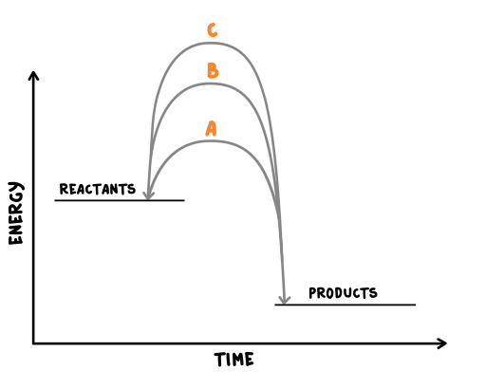
.......................................................................................................................................
.......................................................................................................................................

.......................................................................................................................................

.......................................................................................................................................
.......................................................................................................................................

.......................................................................................................................................

D. Energy changes: exothermic and endothermic reactions
- What is an exothermic reaction? (2)
.......................................................................................................................................
.......................................................................................................................................

.......................................................................................................................................
- Give two examples of exothermic reactions. (2)
.......................................................................................................................................
.......................................................................................................................................

.......................................................................................................................................
- What is an endothermic reaction? (2)
.......................................................................................................................................
.......................................................................................................................................

.......................................................................................................................................
- Give one example of an endothermic reaction. (1)
.......................................................................................................................................
.......................................................................................................................................

.......................................................................................................................................

- Extended response question:
A student wishes to investigate which of three metals will give the largest exothermic reaction when they react with hydrochloric acid. Describe how she would carry out the experiment making sure it was a fair test. (6)
.......................................................................................................................................
.......................................................................................................................................

.......................................................................................................................................

.......................................................................................................................................
.......................................................................................................................................

.......................................................................................................................................

.......................................................................................................................................
.......................................................................................................................................
E. Energy changes: Overall heat energy change for a reaction and calculating energy change
- (HT only) Below is a balanced chemical reaction between nitrogen gas and oxygen gas to produce nitrogen monoxide. The bond energy between two nitrogen atoms is 942kJ/mol, between two oxygen atoms is 494 Kj/mol and between a nitrogen atom and an oxygen atom is 607kJ/mol.
Calculate the overall energy change for this reaction. (4)
N₂ + O₂ → 2NO
.......................................................................................................................................
.......................................................................................................................................

.......................................................................................................................................

.......................................................................................................................................
.......................................................................................................................................

.......................................................................................................................................

- (HT only) Draw a reaction profile for the above reaction. (4)

- Describe the energy release in an exothermic reaction in terms of bond energies. (2)
.......................................................................................................................................
.......................................................................................................................................

.......................................................................................................................................
F. Activation energy and reaction profiles
- What is activation energy? (1)
.......................................................................................................................................
.......................................................................................................................................

- Extended response question:
The following reaction is exothermic:
H₂ (g) + F₂ (g) → 2HF (g)
Draw a reaction profile to show this reaction, including the relative energies of the reactants and products, the activation energy and the overall energy change. (6)

